1. We talk about **Dependency Relationship**.
2. If changes in one of the classes may cause changes to the other.
3. **Dashed Line**:
   1. Used to represent dependency ending with an open arrowhead.
   2. The arrow points to the dependency.  
      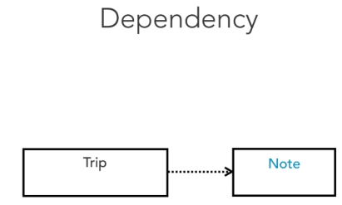
4. Dependency is often confused with relationship but there’s a big difference.
5. Association indicates that a class has attributes of other class whereas dependency is usually created when a class receives a reference to the other class.
   1. For example through a member function parameter.
6. 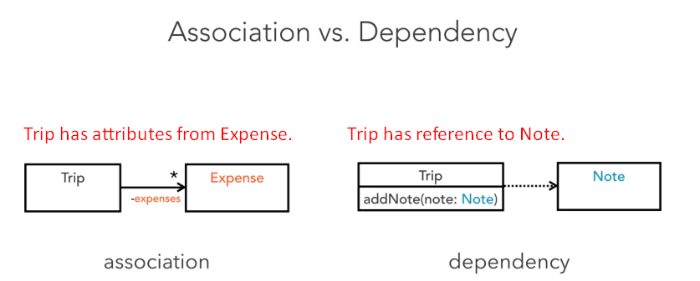
7. 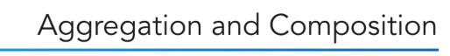
8. Aggregation represents a part-whole relationship and is drawn as a solid line with a hollow diamond at the owner’s end.
9. 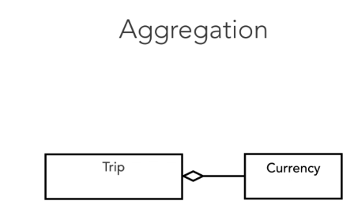  
   This relationship is considered redundant as it expresses the same thing as the association. 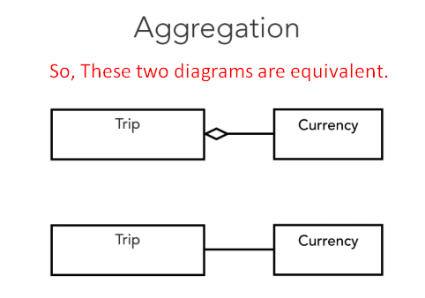
10. **Composition** is stronger form of association.
11. It shows that the parts live and die with the whole.
12. 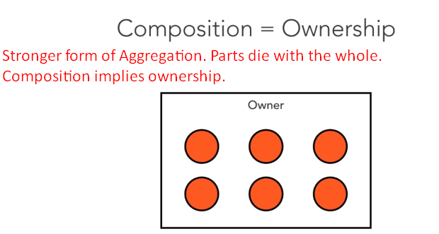
13. 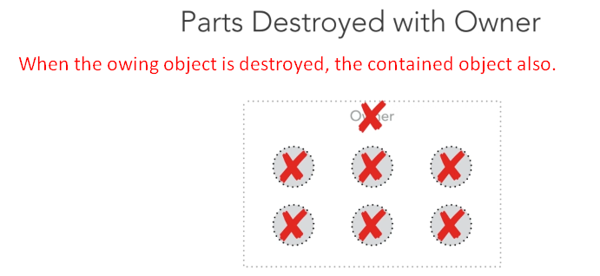
14. 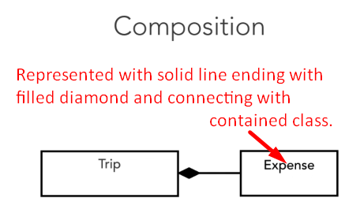
15. 
16. **Realization**: Indicates that a class implements the behavior specified by another model element.
17. It’s represented as a hollow triangle on the interface end and connected with dashed lines with the implementer class.
18. 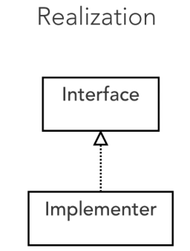
19. We could specify an AbstractTrip type to ensure that all current and upcoming trip classes provide a common set of methods.
20. 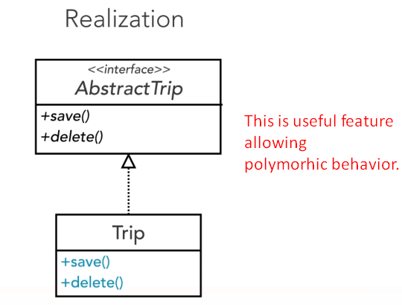
21. 